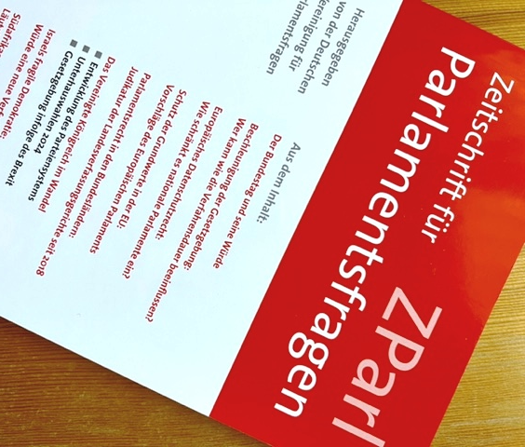

[www.zparl.de](http://www.zparl.de)

Abstract

**Sully, Melanie: The British Party System in Flux**

The British party system has been historically defined by two major parties, the Conservatives and the Labour Party. Parliamentary and election rules have reinforced this dominance which in the twenty first century is facing major challenges. The increasing use of referenda cutting across party lines, electoral volatility and a loss of trust in political institutions mean that even small parties can aspire to break the traditional party system. Issues such as immigration, the environment and international crises further undermine domestic political stability. New parties such as Reform UK with its charismatic leader, Nigel Farage, and a populist agenda but with only an embryonic organisation, have the potential to undermine the two-party system as we know it. Britain is an increasingly polarised society which is reflected in intra-party conflicts. Disputes between party activists, the parliamentary group and rival personalities contributed to the Conservatives’ electoral debacle in the 2024 General Election but the performance of the Labour Party flatters to deceive. A Labour Government that fails to deliver will also feel the wroth of voters. Reform UK poses a significant challenge to the two main parties yet it too has to contend with internal bickering which could thwart its ambition to expand its electoral base. (ZParl, Jg. 55, H. 3)

[www.melanie-sully.at](http://www.melanie-sully.at)